**Milestone 1**

**Group 7**

**Zeel Khokhariya**

**(**[**khokharz@myumanitoba.ca**](mailto:khokharz@myumanitoba.ca)**)**

**Sangmin Lee**

**(**[**lees3430@myumanitoba.ca**](mailto:lees3430@myumanitoba.ca)**)**

**Tinotenda Mpofu**

**(**[**mpofut1@myumanitoba.ca**](mailto:mpofut1@myumanitoba.ca)**)**

**Zach Wolfe**

**(**[**wolfez@myumanitoba.ca**](mailto:wolfez@myumanitoba.ca)**)**

**Dylan Zeng**

**(**[**zengd1@myumanitoba.ca**](mailto:zengd1@myumanitoba.ca)**)**

# **Part (a)**

# **Interactions**

## **Pedestal Fan**

I have a pedestal fan in my room with four buttons to toggle between its four available settings: 3, 2, 1, and 0. Higher numbers correspond to higher fan speeds, with zero indicating that the fan is turned off. The buttons are stacked vertically in sorted order near the centre of the post, where button 3 is at the top and button 0 is at the bottom. Because of this button placement, my interactions with the fan are suboptimal. When I operate the fan from a standing height, they are entirely invisible, obscured by the grill and blades. I also cannot reach them without bending over, which is not ideal. The buttons are labelled with the numbers of the settings to which they correspond. However, like the buttons, the labels are not visible when standing. This makes it difficult to tell what each button does without trying them all. Additionally, the three speed selection buttons each remain pressed down when they are selected, while the off button springs back up. This is a surprising difference in behaviour. In order to work around these problems, I use my hand to feel the top or bottom button, from which I can infer the location of the button I intend to press.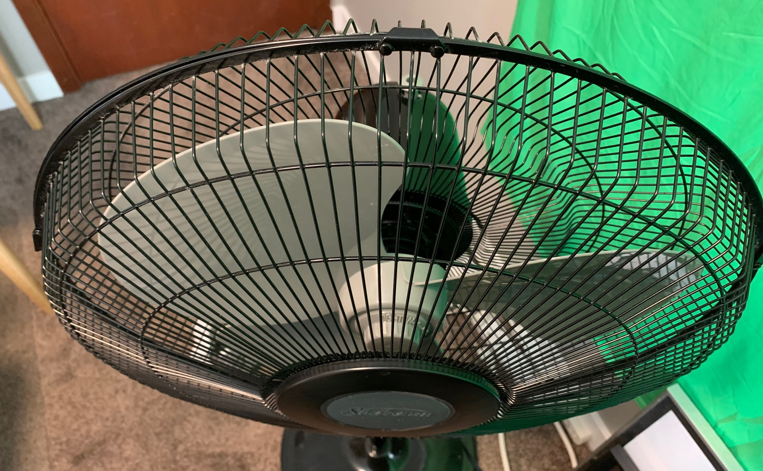

## 

## **Double Fridge Door**

My fridge has two doors side by side, which can be opened and closed independently of each other. In order to make sure that the fridge properly seals despite the double-door design, the left door has a hard plastic block connected to it by a hinge. The block covers the gap between the doors when they are both closed. This is achieved through a guide at the top of the fridge, which causes the block to rotate to fill the gap as the left door is closed, and rotate back when it’s opened, to get out of the way of the right door. However, there is a problem. If the right door is opened first, and then the left, the block does not rotate as far. If one then closes the right door, followed by the left, the block will smash into the right door. My family and I still accidentally do this often, despite having owned the fridge for years. To work around this problem, we manually push the block further in, allowing the door to close.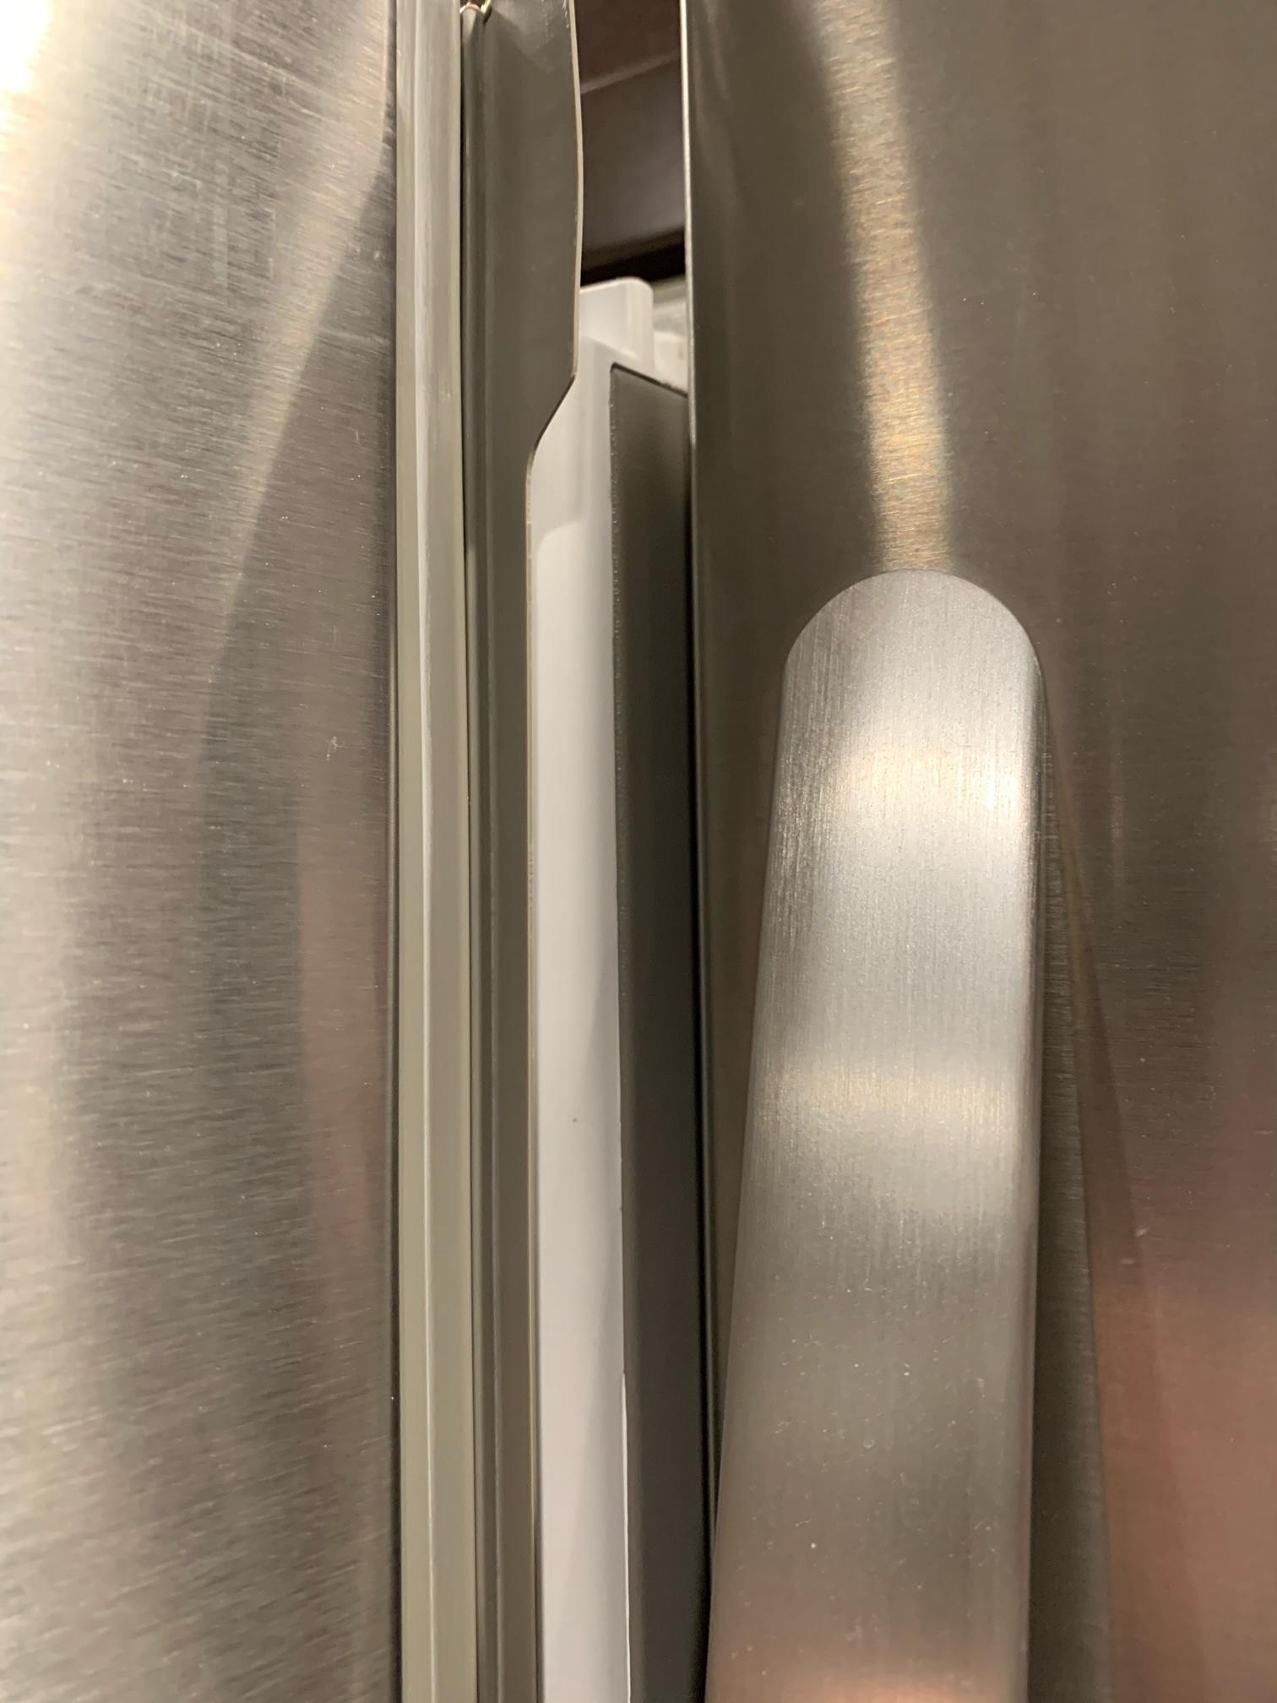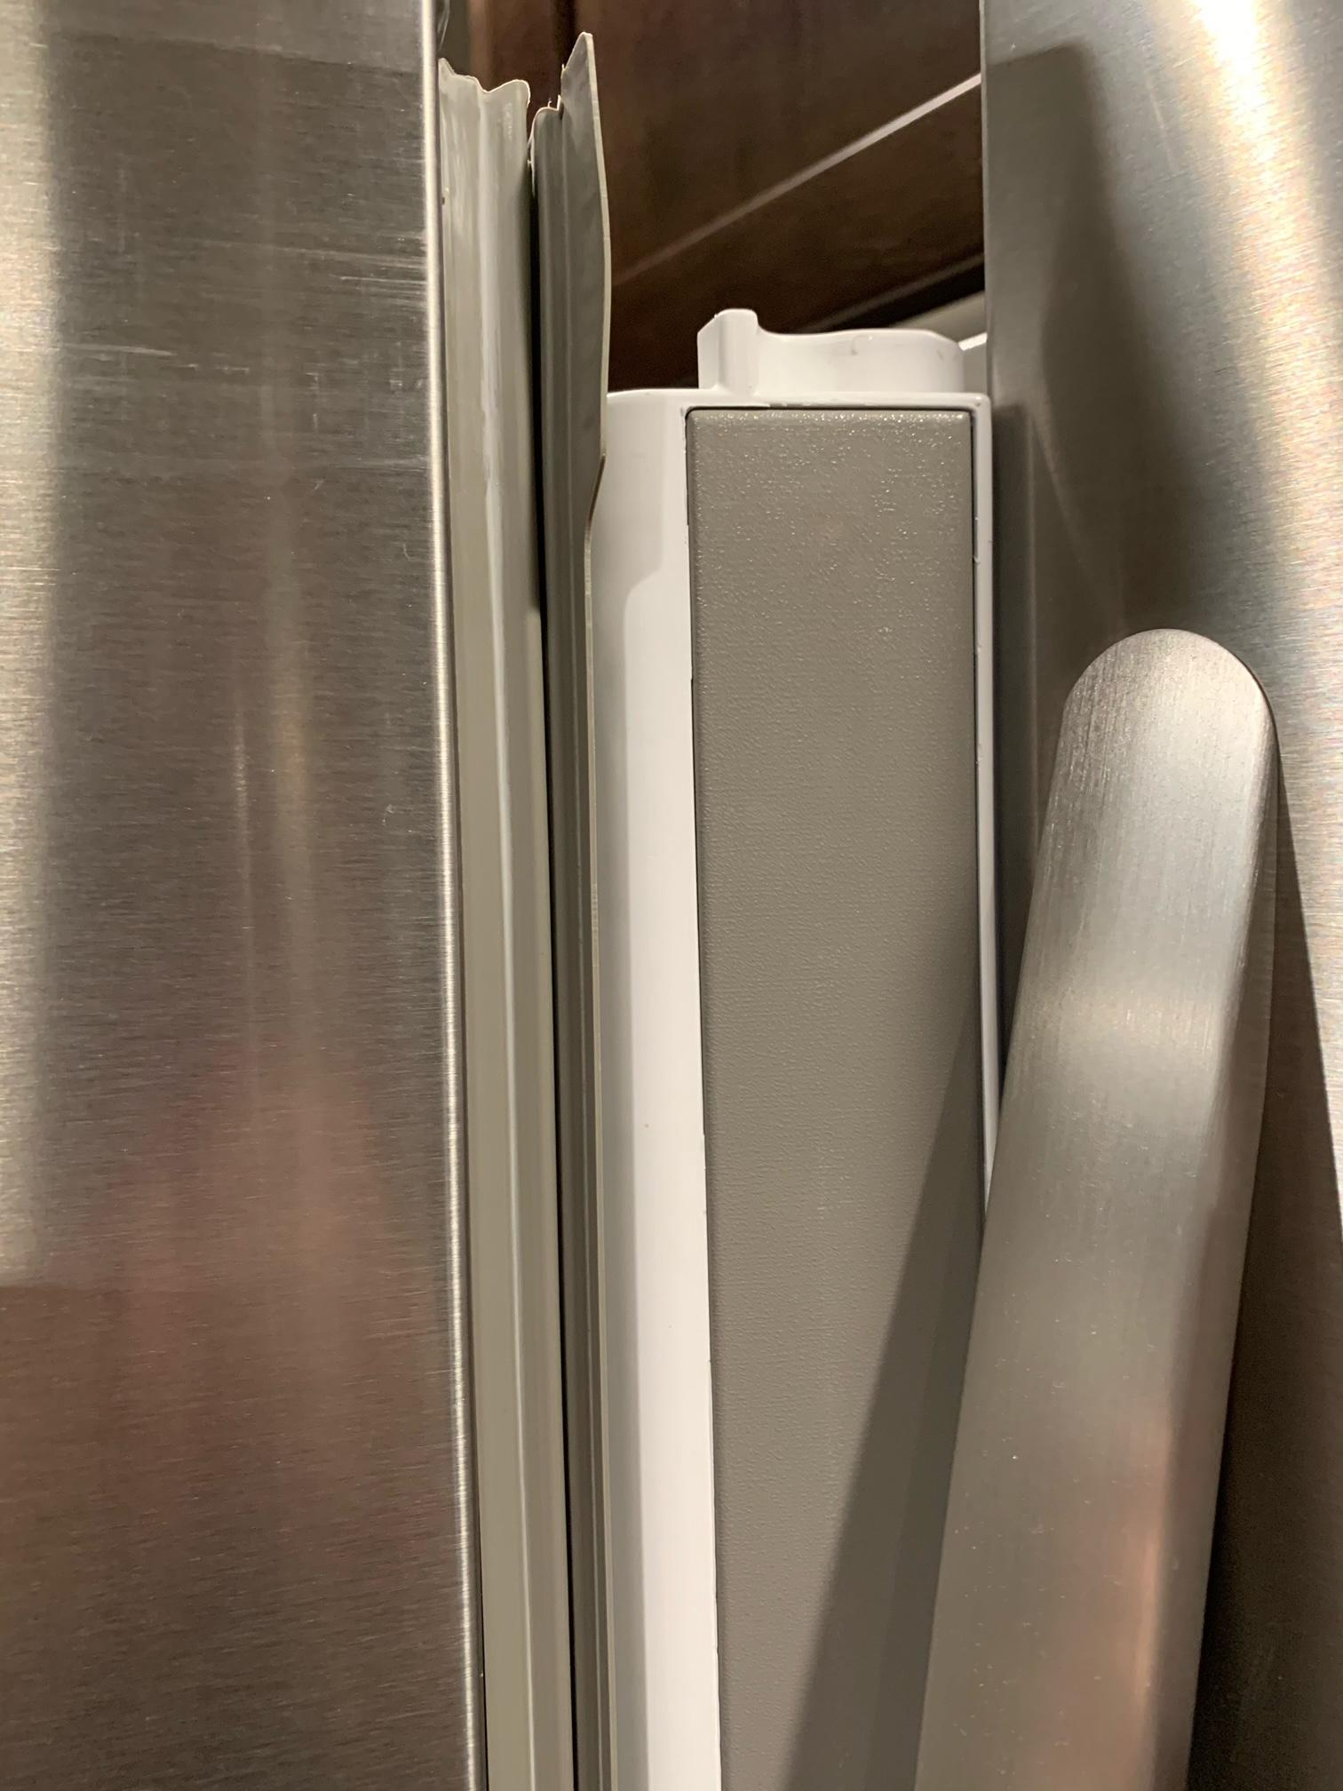

## **Apple Magic Mouse**

Typically, a traditional mouse has two buttons and one wheel for scrolling. However, Apple Magic Mouse has just one button and it also has a touch interface on the mouse. For a first time user, there is a lot of ambiguity on how to use this mouse, since it has just one button. It is well designed for aesthetics, but it is not very well designed for using (heavy, ambiguous, unintended input). There is another really weird design for the charging port. It is located on the bottom of the mouse, so it is impossible to charge and use it at the same time. I overcame these problems by familiarizing myself with it and just using it a lot. I learned how to use this mouse with many different cases and failed lots of times. Also, I charge the mouse regularly before I go to bed.

# 

## **Ikea Sitting/Standing Desk**

This desk has a manual system of raising and lowering it from the sitting state to the standing state. There is no instruction for which direction the user is supposed to rotate the crank for the desk to go up or down. Every time I use this desk, I rotate some direction first and observe whether the desk goes up or down from looking at it, and then I know which direction to rotate it to for what I want the desk to do. This flaw gave me very inefficient experience, so I overcame this problem with labeling the rotating stick with arrows.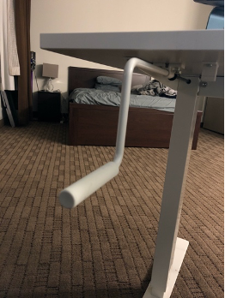

## **Automatic Garage Door (Apartment)**

All cars must have the parking pass to get in and out of the garage door. It is convenient because the door is automatically opened when a car with a pass is approaching the door. However, there is a big issue with the automatic door. When a car is located in the middle of the door, the sensor does not detect the car is still below the door, it automatically shuts the door after a certain time period has passed. Due to this problem, I got some scratches and chips on my back bumper. I was really shocked from this bad experience, so I decided never to proceed with my car if there is another car waiting for the turn and stay behind the door safely.

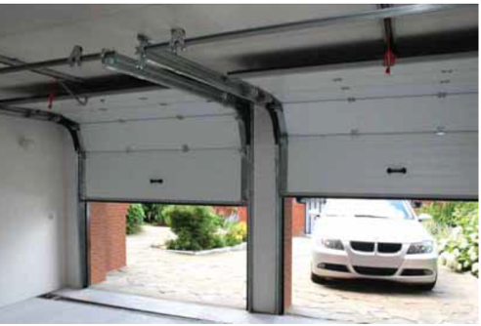

## **USB Connector**

I use one almost every day to connect a mouse to my laptop computer. When I try to plug the USB connector in, I frequently turn it in the wrong way and try to plug it in. I frequently see many people having the same kind of problem. When you try to plug it in the wrong way, it doesn't go in. You just need to flip it over and plug it in but the problem is persistent. I still found myself doing this occasionally, though I know the problem. To overcome a problem, I bought a wireless mouse so, once I plug the wireless USB receiver into the computer, I do not need to reconnect the USB connector whenever I want to use my mouse and I can easily operate my mouse from anywhere.

## 

## **Stove Controls**

At our home, we have a gas stove with four burners. The controls are placed together on the front board but they are not marked which makes it very confusing for me to decide which burner I am trying to operate. One day I was trying to cook and I turned on one of the burners to heat a pan but mistakenly turned on the wrong switch because all controls were together and not even marked so I was so confused when I turned on the wrong burner. This interface was poorly designed and was very confusing. To overcome the problem, I had to test the controls a few times to identify which control starts which burner and I marked down the controls with specific signs and numbers to make the stove easy to operate.

## **Google Maps**

Most of the time, I use Google Maps while I am driving and its voice recognition ability gives me the route and guides me towards my desired location which makes me feel safe while driving. This interface also predicts the estimated arrival time and the best route to my destination based on traffic circumstances. This interface also provides routes to a destination using different modes of transport. I am a student so most of the time busing is my preferred mode of transport. Google Maps detects the best possible route with my other transfer buses and my arrival time to my destination. Thus, interactions with Google Maps are always successful for me.

## **Screen Door**

I have a screen door by the entrance to my apartment. When I am entering or exiting the apartment, I have to go through both the outer screen door and the inner wooden door. The screen door has a mechanical machine attached to it which pulls the door in and tries to keep it shut. It was fairly difficult to open the screen door and hold it open while getting the keys to unlock the door because the force that the machine was pulling the door to close was a lot and this made it hard to get in and out of the house. To deal with this, there is a screw in the machine which allows you to increase or decrease the force of the closing of the door so I decreased it and that made using the door a better experience. Another issue I had with the screen door was it would be difficult to open the outer screen door and then unlock and open the inner door while holding things like grocery bags. To deal with this, I would place my bags on the ground while I unlock and open the door and then I later realized that there was a small metallic hook on the machine which I can slide to hold the machine from closing the screen door. This eradicated the whole problem and after getting inside and putting the things down, I can just undo the hook and the door closes perfectly again.

## **Xbox One Controller**

I use my Xbox One controller when I am playing video games either alone or with some friends. There are multiple buttons on the controller that do different things in the games but for most games I am required to use the thumbsticks to initiate movement in the direction I point the thumbstick towards. A less obvious button on the controller is on the thumbsticks. I can press in each of the thumbsticks and that is another button! With continued use over time, dirt collects inside the controller. The dirt gets in through the spaces around the buttonholes all over the controller. This causes the controller to malfunction. The particular issue I have with this problem is when the dirt collects close to the thumbstick system on the inside of the controller, some actions done on the thumb sticks will be unresponsive (ie. movement) and this gets worse over time as more dirt collects inside. The way to deal with this I have done is carefully opening and cleaning the controller regularly, but I’ve also had to go out and buy a new controller a few times before I did some research and found out I could get some tools and open it myself.

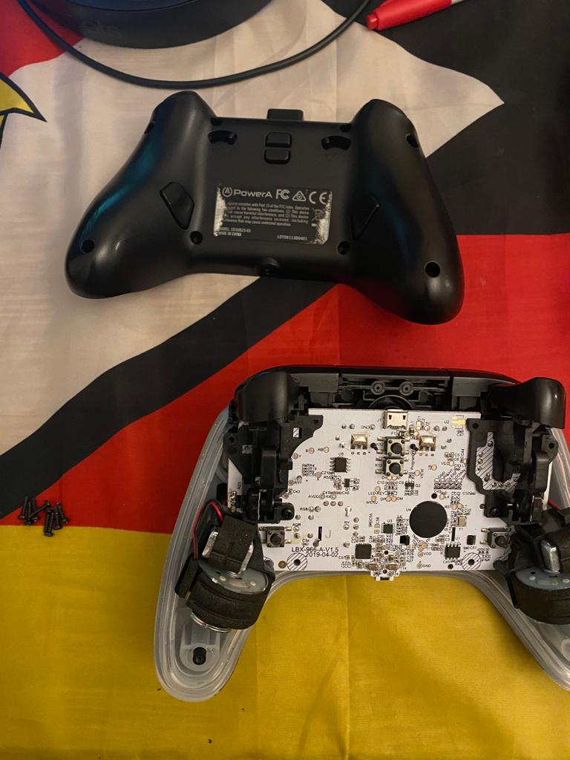

# **Design Principles**

## **Make Common Controls Visible and Accessible**

Controls that are expected to be frequently used should be prominently displayed, and easy to access. In the case of a physical system, this means putting them where during normal usage patterns, they won’t be obscured from view and are easy to reach. For a digital system, this means allowing the user to access the controls in as few steps as possible.

This principle is violated by the pedestal fan. While standing (a very common usage pattern), the speed control buttons (the most commonly-used controls) are obscured from view, and difficult to reach. Relocating the buttons to a more visible, accessible location would improve usability and learnability.

## **Mapping**

Mapping is about the connection between controls and the impact they have on the surrounding. Basically, which control is associated with what action on the product. Mapping helps users to use less knowledge to perform tasks due to the proper arrangement of the controls. Good mapping would not require the need of a label or sign for which control works which function. Moreover, controls should be arranged in the same ways as the items they are controlling. So, users don't need to do trial and error with controls because controls and their connections are obvious.

The mapping principle was violated by some of the bad interfaces from the above interactions. Firstly, the controls of the stove are placed together on the front board, which makes it difficult for the user to decide which knob controls which burner. Instead, if the controls were placed in the same way on the board as the burners, it would help to reduce confusion, trial and error for the user to complete their task. Secondly, Apple Magic Mouse's charging port is wrongly mapped at the bottom of the mouse. Thus, the user can't use the mouse while charging it, hiding the pros of the mouse because of wrongly mapped controls. Nevertheless, the mapping of Google Maps in terms of their control and the control's function is well placed. Google Maps "Search destination" control is well-mapped in the top-center of the design, which makes it easy for the user to search for the destination.

## **Provide fixes for common problems**

Some technology has issues that are guaranteed to come up through just being used over time. For example, a remote control for a television which runs on AA batteries. When those batteries run out, they have to be replaced and the way to do so is easy to do. You can just open the section where they are placed and remove the old ones and insert the new ones. This makes it an easy fix for an inevitable issue. Some more complicated technology have instructions on and provide the means of how to fix these issues, ie. cars and how to perform a tyre change, user manuals provide the steps and most cars come with a jack for lifting the car to perform the tyre change.

This principle is violated by the Xbox controller because the thumbstick issue is a very common problem and they do not provide any suggestions in their documentation for users to use to try and fix the issue. Revising the design of the controller making it possible to pop the controller open with no need for tools could help improve recovery from that problem and

## **Constraints**

Constraints are about modifying the range of interactions for users to mock the interface to work for everything without any limitation. For example, many technology companies are launching their voice recognition services (Apple’s Siri, Amazon Alexa, etc.). Those services look like the users can ask anything they want to ask, however, the voice recognition service can answer only programmed questions or the questions that are on their databases. Those services have guidelines for using their services (expected questions, the questions that work well with their service).

This principle is violated by an automatic garage door. This garage door has sensor range limitation, however, the garage door guides the users to proceed with their car before the door shuts.

## **Feedback**

Feedback is about sending back information about what action has been done and what has been achieved, allowing the user to continue their tasks to achieve a goal. Feedback is all about every action that needs a reaction; that could be audio, visual, verbal, a combination of these, and more. The feedback principle gives the user a clear idea about which action accomplishes which task by giving reaction to action. This principle never leaves the user in a blank spot while the user is trying to achieve the goal. For instance, Spinner is the best example that shows the webpage is loading and spins fast when the webpage is about to load.

The feedback principle is violated by some of the interfaces from the above interactions. Firstly, the automatic garage door sensor's stop identifying car is between the door and closes the door which does not give good feedback to the user's action by giving the bad reaction. Secondly, on the other end, Ikea Sitting/Standing desk is following the feedback principle. Though there is no instruction given on the rotating desk handle, if the user is moving the crank in the wrong direction, the table will give the right feedback by moving the table in the wrong direction. Moreover, the USB Connector is a good example of the feedback principle too when users are trying to insert the connector in the wrong direction, the interface gives the right feedback by notifying the user that it can not enter from this side and they should flip it over then insert it.

# **Part (b)**

## **Participant 1**

Participant 1 is a female nurse between 35 and 55 years of age. She used SkipTheDishes to order food from Salisbury House for a family of five. The interface was pleasant looking, seemed easy to navigate, and did not have any obvious technical malfunctions. On the first screen, the participant was prompted to enter an address. She started typing one, at which point the system displayed a list of recognized addresses matching her entry. She clicked the correct one, and then clicked the button labelled “FIND RESTAURANTS IN YOUR AREA”. Surprisingly, this did not search for restaurants. Instead, it displayed her address on the map. At this point, she paused, expecting the system to advance to the next step. Meanwhile, the system expected her to click the “FIND RESTAURANTS IN YOUR AREA” button again. I had to instruct her to do this, because it wasn’t at all intuitive. One of the food items she selected was the “Cheese Nip Platter”. She wanted two side orders, so she clicked on both. However, the second selection cancelled the first, because the Nip Platter only includes one side. She didn’t notice this, so I pointed it out to her. Unfortunately, there was no way to add a second side within the configuration of the Nip Platter; it would need to be added as a separate item. Upon completing the order, the participant told me that she found the interface “super easy” to use. She didn’t like that it was required to add either cream, milk, sugar or sweetener to coffee, that is, there was no “black” option. She also didn’t like that tea was not listed, despite it being offered in-person. Lastly, she didn’t like that there was no way to easily add more than one of the same item. It should be noted that there was a plus button at the bottom of the item configuration screen for that purpose. She didn’t notice it, however, which makes it worthy of mention.

## **Participant 2**

The participant is a woman, she is in age-range (20-29). She is a student of University of Manitoba. The participant is asked to order poke-bowls from the restaurant called “Pokemono” for 5 people. There are various options for poke-bowl but the participant is asked to order Make-your-own poke-bowl. In order to configure her own poke-bowl, she could easily follow the steps that are structured by SkipTheDishes and it seemed pretty straightforward to order. However, there were 2 things that I observed about the participant that felt uncomfortable. First, the participant forgot to order cutlery at the first time because the website does not tell you will need to order cutlery. At last the participant ordered 5 cutlery, however, the participant took some time to look for the cutlery option (the participant had to go back to the top of the page). Second, the default amount of tip is not set to 0. The participant usually gives a tip to the driver directly when they give a good service to her (right after the food is delivered). Since the default tip amount was not set to 0, the participant had to change the tip to 0 manually. It seemed that the participant was uncomfortable with this experience. There are a few things that the participant talked about that she liked about the interface and did not like. First, the participant liked displaying recent order or frequently ordered items on the first page. She said she usually orders what she orders often, so she felt this interface is efficient. However, there was one thing she did not like about the interface of SkipTheDishes. She is asked to order food for 4-5 people and she had difficulties with splitting the bills among the group members. If she dines in at the restaurant, she can simply ask the server to split the bill, but there is no split option in SkipTheDishes.

## **Participant 3**

Participant 3 is a female aged around 24-27 years old. She is currently pursuing a Master's in Statistics at the University of Manitoba. She is a regular user of DoorDash, so she was asked to use SkipTheDishes to take her out of her comfort zone. She was asked to order food for six people with six different varieties of food from Subway. Firstly, the interface was looking simple to use when it asked "Enter your address" or there was a pin to get the current location. She got confused for a while whether to enter manually or get just by clicking a pin, then she chose to enter it manually. After that, she got a list of all nearby restaurants, and she chose a nearby Subway. She was asked to order two veggie combos. She took 2-3 minutes by clicking to find veggie combos on the menu. The interface asked her to select what veggies to add to the sub sandwich. She completed that step quickly, but she wanted to order two of the same sub. There is no option for quantity. She got angry and had to do all the steps again, which took time for her and was a bad experience. At the end at checkout, a tip was automatically added. She thinks the calculation of the bill was wrong and she was overcharged. The participant’s overall experience in ordering other varieties was awesome, except for not being able to select quantity and the tip being automatically added. The best thing she liked was the selection of topping in the subs was coming in order and they were categorized too.

## **Participant 4**

Participant 4 was a male student in the age range of 20-25 years studying actuarial science at the University of Manitoba. I asked him to use SkipTheDishes.com to order a meal for himself and 3 of his friends with similar food interests as he does. From the “Look” aspect of me observing him navigating the site, it looked like it was an easy and smooth process. I was giving simple nudges where slight confusion would come in. When choosing a restaurant, I had initially stated that he could use any restaurant he felt like using, but the pressure from being watched may have settled in and made the participant a bit nervous when making the decision of where to order from and what to order. I just reminded him that he should just order a meal as he normally would when ordering for himself and a couple of his friends. From how it looked, it seemed like he was already familiar with the website. Address entry worked well, he used a search filter and it worked well and navigation on the list of menu items was done with no problems. The selection of the food had a slight pause when choosing flavours but he figured out what to do without much effort. I asked him to stop after he clicked the “Proceed to checkout” button. When I asked him what he liked during the process, he said he liked that he could filter the search to the specific food item and the results showed where he could get the chicken from. He liked that when in the restaurant page, he could skip straight to the section of the list where what he wanted to order is found. I then asked about what he did not like. He said he did not like that after filtering chicken as the search to find a restaurant, when in the restaurant page, it would show him the full menu instead of the chicken which he had initially entered. He also did not like that after selecting the menu item he wanted, he could not just select the different flavours after specifying the number of orders. He did not like having to repeat the process of selecting the menu item again for all the different flavours.

## **Participant 5**

Participant 5 is a female around 40 years of age, now a housewife. She was asked to use DoorDash to order lunch for her family of 4 people. She usually cooks for all meals in a day and rarely orders food via an app. From my observations, she registered an account and set up her address very quickly. This looked like a good experience for a first-time user. Then, she swiped the categories and picked Japanese food. In the filters, she specified that the restaurant had to be over 4.5 points and the delivery time must be under 30 minutes. After swiping down to browse a few restaurants that satisfy her filter, she selected 4 different ramens in a restaurant, with Tom Yum, chicken, tomato beef and black garlic beef respectively. Then she went to the review page and saw some recommendations, so she added the Takoyaki and fried gyoza. She typed in about an egg allergy in the instructions section and then proceeded to go to checkout. It looked like a seamless process and I did not see any issues with any of the actions she made. When I asked her what she liked about the process, she responded saying she enjoyed the fact that this kind of technology exists and it makes eating out a lot more simple and more comfortable since you can do it from your own home. She also really liked that the delivery was free because she was using the service for the first time. She has an egg allergy, so she appreciated having the extra instruction box so she could mention it with her order. I then asked her what she did not like about the process, and she said she did not like having to enter her address before she could see what kind of food the app had to offer her.

## **Look vs Ask**

In “Look”, we observed that all participants did well at navigating the food ordering systems. Similarly, in “Ask”, we found that all participants thought the systems were fairly easy to use. In general, insights gained about macro-level details tended to be consistent between “Look” and “Ask”. For example, hiccups in the interactions that both the observers and the participants noticed. Where the two approaches differed most was in more subtle, micro-level details: things about the interface that bothered or helped the participant, but that the group members did not notice during the interaction. For example, Participant 1 did not communicate that she wanted to order the same item twice during the interaction; instead, she manually entered it twice. It was only after asking her what she did not like about the interface that she revealed to us she wished she could have added more of the same item. Conversely, there were some details that likely would not have been found out about if we had only asked questions of the participant and had not directly observed them. For example, the issue Participant 1 ran into when trying to get to the list of restaurants: it was clear there was a problem from watching her use the system, but she never brought it up when asked what she did not like about the interface.

## **Overall Summary**

Our observations generally went well. We used slightly different techniques for each participant. For example, some of the interactions were filmed, while others were simply observed by group members taking notes. The former was helpful for capturing nuances that the group members did not notice at the time. Participant 2 was given a simple questionnaire after her interaction instead of directly being asked questions. We found this to be too restrictive, because the questionnaires were limited to certain areas. In the future, we believe it would be preferable to ask specific questions relevant to the user’s interaction. Additionally, the participants varied widely in their levels of experience with the specific systems they were asked to use, as well as with online food ordering systems in general. Participant 1 had never used an online food ordering system before. Others, like participants 3, were regular users of other food ordering systems, but not the one they were asked to use. Meanwhile, Participant 2 and 4 were regular users of SkipTheDishes, the website they were asked to use. This diverse array of experience levels contributed to a wide range of valuable data. We also learned that predicting what a user will do is really difficult. For example, we believed Participant 2 would not notice the default tip amount, but it turned out that the participant already knew there was a tip section and changed the tip amount.

**Appendix**

# **Zach’s Interactions**

## **Pedestal Fan**

I have a pedestal fan in my room with four buttons to toggle between its available settings: high, medium, low, and off. The buttons are stacked vertically near the centre of the post. Because of this, from a standing height, the fan grill and blades block my view of the buttons entirely, so I have to exclusively rely on tactile feedback to locate and press the correct button. Despite not being a very tall person, I have to bend over to reach the buttons. It also isn’t immediately obvious what each of the buttons do without trying them. They are labelled in order with a number from 0 to 3. However, these labels are only visible at eye level, because like the buttons, they are covered when standing. The labels aren’t visible from the left either, because the buttons protrude by about a centimetre. Additionally, the three speed selection buttons each remain pressed down when they are selected, while the off button springs back up. This is a surprising difference in behaviour.

## **GitHub Issues**

I was trying to edit an issue on the mobile GitHub site, but I couldn’t find an edit button anywhere. I tried scanning the page for a second time and came across an ellipsis (...) button, which then brought up a menu that contained only an edit button. I assume that the menu is generic and context-sensitive, that is, other users might see more buttons. Regardless, in my case, the ellipsis button served only to obfuscate the functionality I wanted to access. My experience would have been much better if there was an obvious edit button.

## **iCloud Notes (Web Version)**

Switching the active window from Notes to another program and back again loses the text focus. Because of this, every time I Alt-Tab back to the window, I have to click on the place in the text field where I want to edit.

## **Fridge Water Dispenser**

My refrigerator has a built-in water dispenser, which provides a convenient way to fill a glass with filtered tap water. However, the dispenser doesn’t always stop dispensing water immediately. Instead, it seems to fill to the next integer unit of water, i.e. fluid ounce. If the cup is already nearly full and a new unit has recently begun, that extra fraction of a unit often causes the cup to overflow.

## **Double Fridge Door**

This one is difficult to explain, but I’ll try my best. My fridge has two doors side by side, which can be opened and closed independently of each other. In order to make sure the inside of the fridge is isolated from its environment despite the double-door design, the left door has a hard plastic block connected to it by a hinge. The block covers the gap between the doors when they are both closed. This is achieved through a guide at the top of the fridge, which causes the block to rotate to fill the gap as the left door is closed, and rotate back when it’s opened, to get out of the way of the right door. However, there is a problem. When the right door is opened first, and then the left, the block does not rotate far enough. If one then closes the right door, followed by the left, the block will smash into the right door. This behaviour is hard to learn, as evidenced by the fact that my family and I still accidentally do this often, despite having used the fridge for years.

## **Apple Calendar (iOS)**

I find most tasks I need to do require many taps. Important information, such as which calendar an event is a part of, is not always displayed in places where it would make sense to do so. This does provide for a nice-looking, clean interface. However, I don’t think that is worth the sacrifices to usability.

## **Aurora**

Aurora is extraordinarily difficult to learn, and extraordinarily unmemorable. Navigation is performed primarily by navigating a tree of links. Each link is purely textual, with no icon or image associated with it. This makes it impossible to tell at a glance what each link leads to; the only solution is to read them all. Often, it is not even clear which link will lead to the desired function. For example, is my booklist found under “Registration and Exams” or “Student Records”? The former makes the most sense to me, but the latter is the correct answer. The only way to find that out is to guess, and try the other option if you’re wrong.

## **Mouse**

My mouse has four buttons to adjust DPI (relates to mouse speed). I never adjust DPI, so I have only ever hit them accidentally. When that happens, I have to waste a few seconds to get it back to how I like it.

## **UNIX-Based Consoles**

For historical reasons, standard keyboard shortcuts such as Ctrl-C and Ctrl-V for copy and paste, respectively, do not work on UNIX-based consoles. This inconsistency in behaviour compared to the rest of the system can be frustrating.

## **Nintendo Switch eShop**

The Switch eShop, used to purchase games, has become quite unresponsive. The framerate is very low, and it often takes well over a second to respond to a button press. This probably makes a lot of people purchase fewer Switch games, because the experience of browsing the shop is so unpleasant.

# **Zeel’s Interactions**

## **Google Maps**

Most of the time, I use Google Maps while I am driving, and its voice recognition ability gives the route and guides me towards the desired location which makes me feel safe while driving. This interface also predicts the estimated arrival time and the best route to our destination based on traffic circumstances. This interface also provides routes to a destination using different modes of transport. I am a student so most of the time I use the bus as my prefered mode of transport. Google Maps detects the best possible route with my other transfer buses and my arrival time to my destination .Thus, my interaction with Google Maps is always successful for me.

## **Starbucks Mobile App**

I use the Starbucks app at least once a week, and rarely do I use the option for the full menu, I look at the “Featured” tab to see if there is anything new and then I select what I want from the “Recents” tab. I love the Starbucks app, especially when I compare it to the Tim Hortons app, where I have to sort through the full menu every time. Both apps allow adding items to a favorites list, but that requires an extra step and is never a complete list of what I am likely to want.

## **USB Connector**

I use one almost every day to connect a mouse to my laptop computer. When I try to plug the USB connector in, I frequently turn it in the wrong way and try to plug it in. I frequently saw many people have the same kind of problem. When you try to plug it in the wrong way, it doesn't go in. You just need to flip it over and plug it in. But the problem is persistent. I still found myself doing this occasionally, though I know the problem. To overcome a problem, I bought the wireless mouse so, once I plug the USB chip in further, I can easily operate my mouse from anywhere.

## **My Vehicle Controls** (to open gas top and front trunk)

Whenever I go to a gas service station to refill gas for my vehicle. My vehicle controls every time upset me. Every time I open the front trunk instead of opening the gas top. These two controls are side by side at the bottom between the door and the driver’s seat. To beat my problem, I have to move my seat back and search for the right control. If the controls were designed on the dashboard and separate from each other there was less chance to commit an error.

## **Stove Controls**

At our home, we have a gas stove with a four-burner. The controls are placed together on the front board and even controls are not marked which makes it very confusing for me to decide which burner I am trying to operate . One day I was trying to cook, and I turned on one of the burners to heat a pan but mistakenly turned on the wrong switch because all controls were together and not even marked so I was so confused in deciding which control states which burner. This interface was poorly designed and confusing. To overcome the problem, I had to test controls a few times to identify which control states which burner. To overcome this, I marked down the controls with specific signs and numbers to make it easy to identify.

## **Touchless Car Wash Machine**

Whenever I want to wash my car, I go to the nearest Touchless Car Wash station. When i am there, I have to enter the code generated by the car wash system so I can connect my car to their system. Once I press start from the app and then the entrance is automatically open. The system detects the car and provides further instruction. The car is first rinsed with water then soap is sprayed, the car is properly washed within a few minutes. Throughout this process, the user is provided with instructions by the app. In the end, the user is instructed to slowly exit the car wash. The best part is without keeping foot out of the car you can properly wash your car. This system is efficient because it only takes 5 minutes to wash a car while other manual car wash takes a minimum of 30 minutes to wash a car.

## **Parking Ticket Dispenser**

I was having a bad experience with the parking ticket Dispenser at Downtown. The dispenser’s controls were badly misplaced without considering the user in mind. The dispenser’s payment machine was at the bottom of the machine. So, every time I want to pay for the parking, I have to come out of the window, and many times I accidentally drop my card down due to less space. To overcome this problem, I started to pay for parking online and I sometimes come out of the car and pay for my parking.

## **NetBeans**

At my early stage of programming in Java, I was using the BlueJ for the programming in which every time I have to remember every syntax even for a small semicolon mistake program doesn’t compile. And I used to feel I would never learn to program in Java. Then, My friend suggested that I use Netbeans for Java. It was simple and even suggested the syntax with description which helps me to learn code faster. And this debugging tool helps me to find bugs in the code quickly and solve the problem. So, with Netbeans, I used to have one of the good experiences.

## **Scientific Calculator**

During my early university days, I went to my first statistics class. There, my professor taught me to solve the variance problem using the normal calculator which feels tough to solve. At the end of my class professor introduces the scientific calculator to the class. The calculator has too many features while we can save anything and reuse it. By using that calculator, I was able to solve the variance problem with 3 minutes so that was one of my good experiences. Even the features were so easy to use.

## **My Econ Lab learning website**

My interaction with the sapling learning website during Econ 1010 class was awful. I was having the access code of the website. So, I enter my professor's information so I can enter my access code and start using it. However, the website didn't give the option to enter the access code and it was so poorly designed and unmanaged. I tried several times every time it gives the option to pay and use no about the access code. I was tired of it and I contacted the professor who then sent me a link. I entered my access code then I was able to access the course assignments.

# **Sangmin’s Interactions**

## **Apple magic mouse**

Typically, a traditional mouse has 2 buttons and 1 wheel for scroll. However, Apple magic mouse does have just one button and it even has a touch interface in the mouse.For the first time user, it is very ambiguous how to use this mouse, since it has just one button. It is well designed for aesthetics, but It is not well designed for using. (heavy, ambiguous, unintended input). There is another really weird design for charging ports, it is located in the back of the mouse, so it is impossible to charge and use at the same time.I overcame these problems by just using lots of time. I learned how to use this mouse with many different cases and failed lots of times. Also, I charge the mouse regularly before I go to bed.

## **Apple pencil 1st generation**

The Apple pencil 1st generation has some flaws in design.

1) The way to charge the pencil is silly. (it looks like a fan)

2) The cap on the top of the pencil can easily disappear.

Overcome

1) Make it wireless charging (2nd generation does it)

2) Change the way to open and close with rotating, not the magnet.

## **Starbucks Verismo Capsule machine**

I have been using this machine for 3 years, I am still confused with the buttons sometimes. There are three buttons on the machine which are an espresso button, brew coffee button and milk pod button. The way they describe each function is really ambiguous. They need to change the picture on the button or put the letter beside the button.

Overcome

1) Change the button picture unambiguously.

2) Put the function name beside the button. (Espresso, brew coffee, milk pod)

## **Ikea sitting/standing desk**

This desk has a manual sitting/standing desk function, there is no instruction for which direction should customers rotate to. Every time when I use this desk, I rotate some direction first and see where the desk goes (up/down) by my eyes, and then I know which direction is for going up. This flaw gave me very inefficient experience, so I overcame this problem with labeling the rotating stick with arrows.

## **Microwave**

This microwave has two buttons. There is no instruction on or beside the button so it is not straightforward to use. I still need to think what this button works for.

Overcome

1) Give instructions beside the button

## **Harman/Kardon Bluetooth speaker**

This speaker has few buttons but it is hard to see and control it. The buttons are not noticeable at night because they do not physically exist. (it is just printed with the logo). It is really hard to recognize where the button is. When you press the volume button, there is no proper feedback to users if the button is successfully pressed or not.

Overcome

1) Make buttons to be engraved or embossed.

2) Change the feedback for button press to vibration.

## **Shower faucet**

This Shower faucet has no instruction for hot/cold water. For the first-time user, they will have to investigate how to get hot/cold water. Furthermore, there is no direction indication for rotating so users can accidently rotate to the direction that does not work.

Overcome

1) Put the direction indicator (right – open the faucet)

2) Put the colour for hot/cold water (hot-red, cold-blue)

## **Window Shades**

It is very hard to control the Window Shades if you are the first-time user, even people who have been used for a long time, it is really confusing to control window Shades.

Overcome

1) Make a more easier way to control the window shades.

## **Automatic sanitizer machine**

It is convenient to use, good for prevention purposes (no direct contact) but It does not work in certain cases. For example, the machine runs out of the battery, so people cannot use the sanitizer. Another example is that the sensor is blocked with something or sanitizer bubbles, so people cannot use it.

Overcome

1) Add the manual function in case of running out battery.

## **Automatic garage door(Apartment)**

All cars must have the parking pass to get in and out. It is convenient because the door is automatically open when the car is approaching the door. However, there is a big issue with the automatic door. When a car is located in the middle of the door, the sensor does not detect the car is still below the door, it automatically shuts the door after a certain time period has passed. Due to this problem, I got some scratches and chips on my back bumper. I was really shocked from this bad experience, so I decided never to proceed with my car if there is another car waiting for the turn and stay behind the door safely.

# **Tinotenda’s Interactions**

## **No Netflix on my tv**

I have an older tv in my lounge so I don’t have some functions like Netflix built into the tv. I bought a Google Chromecast which I connect to the tv and when you switch to the HDMI channel that the device is connected to, it allows you to cast whatever show you are trying to watch to the chromecast and displays it on the tv.

## **The screen door**

I have a screen door by the entrance to my apartment. It has a mechanism where it closes and stays shut on its own. It is fairly difficult to open the screen door and hold it open while getting the keys to unlock the door while losing things so there is a way to hold the door open by stopping the mechanism from closing the door on its own allowing me to freely open the doors and enter into my apartment and I can then undo the hold on the screen door.

## **The soap holder in my shower**

When showering I need a convenient place to put my soap when I am washing up. There is a soap holder in my bathroom but it isn’t big enough to hold a liquid soap bottle and I use liquid soap so the way I deal with this is just placing my bottle on the edge of the tub and being careful not to knock it over.

## **The hot water faucet on my bathroom sink**

My hot water faucet got corroded a few months ago and I had to get it replaced and it was replaced in such a way that to open it you twist it clockwise while every other faucet opens by twisting anti clockwise. It is confusing sometimes and the way I deal with it is by trying to open it like it’s normal and realizing that I have to twist to the other side.

## **My bedroom rug**

I have a small rug in my room and it’s by the side of my bed. I walk over it very often and it somehow moves further and further away from my bed on the ground. I deal with this by regularly dragging it back into place.

## **No painting hooks in my room**

My bedroom is pretty bland and I wanted to decorate it with some paintings I have done over the years but there were no hooks or nails for me to hang the paintings onto. I dealt with this by buying some stick on hooks that have an adhesive which sticks onto the wall.

## **No light socket in my bedroom**

In my bedroom there is a light switch by the door but it operates a specific wall socket instead of the traditional light socket somewhere in the room and i overcame this issue by getting a floor lamp which i connect to the socket operated by the light switch so I operate it with the light switch and can use the switches on the lamp as well.

## **My Xbox controller**

I use my Xbox controller when I’m gaming either alone or with some friends. For most games, I am required to use the thumb sticks which rotate on an axle for movement and I’m game actions. There’s a space which allows for rotation on the controller and over time, dirt collects inside the controller and causes jams on the mechanism which gets worse over time. The way to deal with this I have done is cleaning the device regularly but I’ve also had to go out and buy a new controller :(

## **My water bottle cap**

I have a smooth metallic water bottle with a smooth metallic cap and the bottle is opened by twisting the cap anti clockwise. This interaction is not successful whenever I close the bottle very tightly. This is due to my hand slipping on the cap because of the smooth finish. I deal with this issue by not closing the bottle very tightly but it creates a hazard of the contents of the bottle spilling.

## **Round/circular door knobs**

In my apartment there’s circular door knobs that are operated by twisting the knob either to the left or to the right to open the door. It’s usually a successful interaction but it is not very good if I don’t have a free hand to grip the knob. I don’t have a free hand when I’m carrying things with both hands and I overcome this by carrying less things when I’m opening the door.

# **Dylan’s Interactions**

## **Aurora Classes Look Up System**

When I want to look up the courses, I have to select the term and the subject, as well as clicking the “Course Search” button after each input. It takes me 6 clicks to go to the course list page, which is very inconvenient and time-wasting. I hope that both term and subject selection could show up in the same page and the system could save the searching history as the default selection. It needs only one click for the user to get to the course list page.

## **Aurora Online Transfer Credit Resource**

When I want to search up the information about transfer credit, I need to pick an institution first, which is in a list of hundreds of institutions showing in a tiny dialog box. It could not satisfy my needs of seeing where I can take a specific course. Furthermore, the small selection dialog box gains the difficulty of using, making the user’s eyes tired. The interface could be better if we can search institutions by courses and the selection dialog box could be larger.

## **WhatsApp Chat Interface**

WhatsApp is a popular communication app and I really like the chat interface. The chat bubbles allow the time showing at the end of the last line of the text if space allows, rather than showing on the next line. Also, the distance between two bubbles, and the distance between the last line of a text and the bottom of the bubble are very short. The designs above could save space, so that more information could be shown on the screen.

## **Nintendo Switch Joy-Con Controller**

The controller is too small for me and I cannot expand my hands comfortably while using it. The buttons are closed to each other so it makes the users easily press the wrong one, which could be disastrous in some competitive games.

## **Tik Tok**

You can watch the videos once you go into the app. And some basic operations are quite easy, such as swiping up to see the next video, swiping down to see the previous video, swiping left to see the profile of the creator. It simplifies the interface to the largest extent, so there is more space for the videos. Also, the strong algorithm could generate a stream of videos that the user might be interested in, which allows the user to enjoy it while doing less.

## **Sony WH-1000XM3 Headphones**

This is the headphones I am currently using and I would put it to the list of convenient devices. I can use the touch sensor control panel to perform a lot of operations, such as increasing and decreasing the volume by swiping up and down, controlling play and pause by double tapping the control panel, going to the next and previous song by swiping forward and backward. All these operations are very simple, which allows me to control the audio device without taking it out of my pocket.

## **The Drawers of My Desk**

I love the drawers of my desk since it is really a good design. It is so smooth so I only need to push it lightly, then it could continue to slide back. When there is about 3cm left, it would be attracted to shut and closed tightly.

## **My bottle**

The top of my bottle is slightly wider than the bottom, and the dimension of the rim is large enough for me to put my hand inside, which is convenient for me to wash the inner face.

## **Pop Can**

I love drinking coke, so the pop cans are frequently used. The slightly frozen coke is my favourite so I often put the cans with coke in the refrigerator for about 2 hours to make it to a nice temperature. However, I would forget to take it out sometimes and the coke would be totally frozen. As we know, the volume of ice is bigger than the volume of water if they are equal in mass. So, the can would probably burst by the increasing volume of the coke. To my surprise, it didn’t. I noticed that the bottom of a pop can is curving in, which provides space for the extra volume of the ice. After the coke turns into ice, the bottom would be curved out to prevent the can from bursting.

## **YouTube App**

I have to say that the YouTube app is a good design. The users could see their watching history and put the videos they like into a file for watching in the future. And there are also recommendations in the first page and beneath the video you are watching.